COS40007 Artificial Intelligence Engineering
Portfolio Assessment 2
Advanced Data Preprocessing, Feature Engineering & Model Development
Dataset: Appliances Energy Prediction (UCI Machine Learning Repository)
Student name: Dinh Phu Nguyen
Student ID: 105027282
Lecturer: Dr. Duc Tho Mai
Unit: COS40007 Artificial Intelligence Engineering
Task: Portfolio Assessment 2
Submission date: 18/10/2026
GitHub repository: https://github.com/phu1009/COS40007---AI-Engineering-

Acknowledgement of Country
We respectfully acknowledge the Wurundjeri People of the Kulin Nation, who are the Traditional Owners of the land on which Swinburne's Australian campuses are located in Melbourne's east and outer-east, and pay our respect to their Elders past, present and emerging.
We are honoured to recognise our connection to Wurundjeri Country, history, culture and spirituality through these locations, and strive to ensure that we operate in a manner that respects and honours the Elders and Ancestors of these lands.
We also respectfully acknowledge Swinburne's Aboriginal and Torres Strait Islander staff, students, alumni, partners and visitors.
We also acknowledge and respect the Traditional Owners of lands across Australia, their Elders, Ancestors, cultures and heritage, and recognise the continuing sovereignties of all Aboriginal and Torres Strait Islander Nations.
Generative AI Use Declaration
"I used Claude (Anthropic) to assist with, analyzing rubric requirements. All final code, interpretations, and conclusions are my own work after verification."
Evidence of the GenAI use is provided in Appendix A.

Advanced Data Preprocessing, Feature Engineering & Model Development Report
1. Introduction
This report continues the exploratory analysis of Portfolio 1 (PA1) on the Appliances Energy Prediction dataset: 19,735 ten-minute readings (11 January – 27 May 2016) of the appliance energy use of a low-energy house in Belgium, with indoor temperature and humidity from a wireless sensor network and outdoor weather data (Candanedo et al., 2017). The data is cleaned exactly as in PA1 (date converted to datetime; rv1, rv2 and the faulty RH_6 sensor removed; no rows removed), leaving 24 original predictors. The goal is to classify each reading into Low, Medium or High consumption, following the Studio 3 workflow: preprocessing, feature engineering, five Decision Trees that isolate one preprocessing step each, then an SVM improved with kernel selection, hyperparameter tuning, feature selection and PCA. References to the PA1 notebook are written as PA1 §x.y.
2. Target Variable Preparation (Task 1)
Appliances (Wh per 10 minutes) is numeric, so it was discretised into three classes (brief option 1.1). The binning is based directly on the PA1 EDA:
- The target is strongly right-skewed (skewness 3.39; mean 97.7 Wh vs median 60 Wh) and recorded in 10 Wh steps, with 22% of readings exactly 50 Wh (PA1 §3.2).
- Equal-width binning put 96.2% of readings into one class. Equal-frequency binning with 3 classes gave the best balance (balance ratio 0.81, vs 0.44 for 4 classes and 0.21 for 5 classes) (PA1 §3.3).
- The boundaries (50 and 80 Wh) have a physical meaning: the night-time base load has a median of exactly 50 Wh, and the 17:00–20:00 cooking peak lies above 80 Wh (PA1 §3.3, hourly profile).
Table 1: Target classes (equal-frequency binning of Appliances).
Class | Range (Wh / 10 min) | Average power (W) | Readings | Share | Median (Wh)
Low | 10–50 | 60–300 | 7,462 | 37.8% | 50
Medium | 60–80 | 360–480 | 6,047 | 30.6% | 60
High | 90–1,080 | 540–6,480 | 6,226 | 31.5% | 120

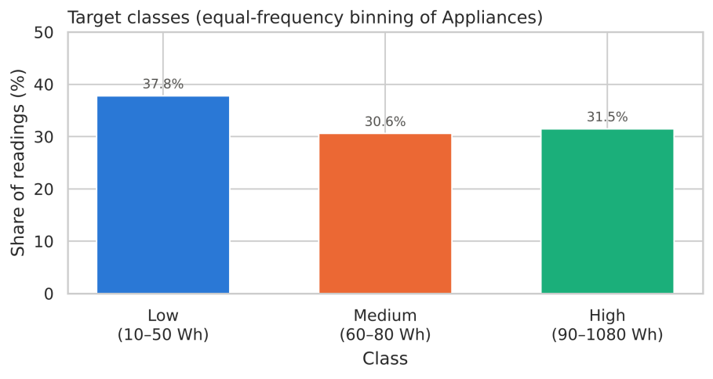
Figure 1: Class distribution of the target (balance ratio 0.81).
Expected difficulty. Medium covers the narrowest range (60–80 Wh) and lies between the other two classes, so it is likely to be the hardest class to predict. The labels are ordinal (Low = 0 < Medium = 1 < High = 2).
3. Feature Normalisation and Encoding (Task 2)
3.1 Scaling choice for each feature
Each continuous feature was assigned a scaler from its EDA distribution (PA1 §4.3 skewness and share of zeros; PA1 §2.4.2 share of IQR outliers), using the rules: zero-inflated (> 50% zeros) or outliers > 5% or |skew| ≥ 0.5 → the brief recommends MinMax/Robust; approximately symmetric → StandardScaler. Table 2 lists the decision for every original feature, including the final choice used in the models (explained in Section 3.3). All scalers are fitted on the training data only, inside scikit-learn pipelines.
Table 2: Scaling decision for each original feature (based on the PA1 EDA).
Feature | Skew | IQR outliers | Zeros | EDA shape | Brief scaler | Final scaler
lights | +2.20 | – | 77% | zero-inflated | MinMax | Yeo-Johnson
T1 | +0.12 | 2.6% | 0% | approx. symmetric | Standard | Standard
RH_1 | +0.47 | 0.7% | 0% | approx. symmetric | Standard | Standard
T2 | +0.89 | 2.8% | 0% | skewed | MinMax | Yeo-Johnson
RH_2 | -0.27 | 1.2% | 0% | approx. symmetric | Standard | Standard
T3 | +0.45 | 1.1% | 0% | approx. symmetric | Standard | Standard
RH_3 | +0.47 | 0.1% | 0% | approx. symmetric | Standard | Standard
T4 | +0.17 | 0.9% | 0% | approx. symmetric | Standard | Standard
RH_4 | +0.44 | 0.0% | 0% | approx. symmetric | Standard | Standard
T5 | +0.56 | 0.9% | 0% | skewed | MinMax | Yeo-Johnson
RH_5 | +1.87 | 6.7% | 0% | outliers > 5% | Robust | Yeo-Johnson
T6 | +0.60 | 2.6% | 0% | skewed | MinMax | Yeo-Johnson
T7 | +0.25 | 0.0% | 0% | approx. symmetric | Standard | Standard
RH_7 | +0.24 | 0.2% | 0% | approx. symmetric | Standard | Standard
T8 | -0.26 | 0.4% | 0% | approx. symmetric | Standard | Standard
RH_8 | +0.31 | 0.1% | 0% | approx. symmetric | Standard | Standard
T9 | +0.38 | 0.0% | 0% | approx. symmetric | Standard | Standard
RH_9 | +0.37 | 0.1% | 0% | approx. symmetric | Standard | Standard
T_out | +0.53 | 2.2% | 0% | skewed | MinMax | Yeo-Johnson
Press_mm_hg | -0.42 | 1.1% | 0% | approx. symmetric | Standard | Standard
RH_out | -0.92 | 1.2% | 0% | skewed | MinMax | Yeo-Johnson
Windspeed | +0.86 | 1.1% | 0% | skewed | MinMax | Yeo-Johnson
Visibility | +0.44 | 12.8% | 0% | outliers > 5% | Robust | Yeo-Johnson
Tdewpoint | +0.24 | 0.1% | 1% | approx. symmetric | Standard | Standard

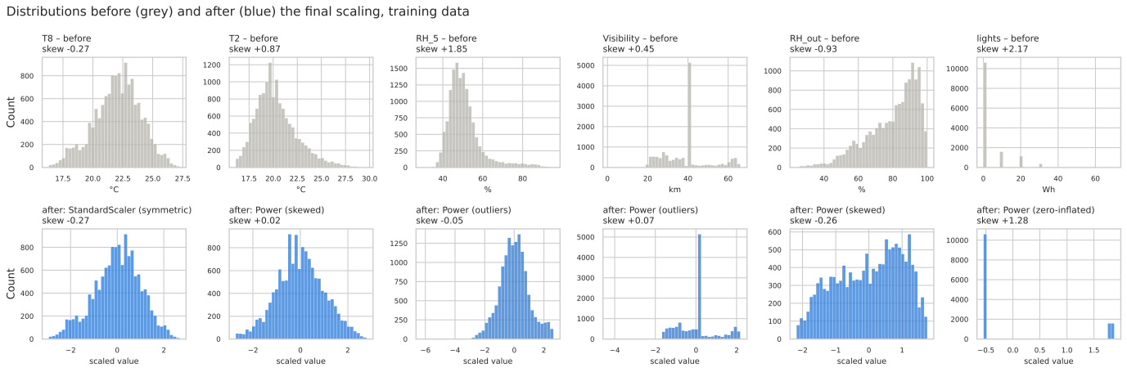
Figure 2: Distributions before (grey) and after (blue) the final scaling for one feature of each type (training data).
3.2 Encoding
All 24 original predictors are numeric. The non-numerical information is the timestamp and the class label (Table 3).
Table 3: Encoding of non-numerical information.
Source | New feature(s) | Type | Encoding | Reason
date → hour | hour_sin, hour_cos | cyclic | sine / cosine | 23:00 and 00:00 must be neighbours; hour of day is the strongest driver (η = 0.387, PA1 §5.2.1)
date → period of day | 5 × period_* (night, morning, afternoon, evening, late evening) | nominal (5) | one-hot | Routine phases from the hourly profile (PA1 §3.3); < 10 categories, no order
date → day of week | is_weekend | binary | 0 / 1 | Weekday vs weekend routine (PA1 §5.2.1)
Appliances_class | y | ordinal | Low = 0, Medium = 1, High = 2 | Natural order of the classes

3.3 Impact of scaling on model performance
Decision Trees split on one feature at a time, so they are scale-invariant. An RBF-SVM compares readings by Euclidean distance, so features with a larger spread get more weight. Four strategies were compared with a default SVM on the same 70/30 split (Figure 3).
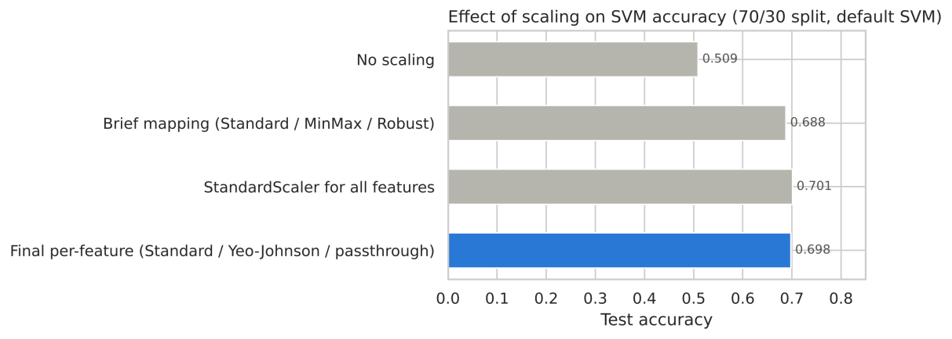
Figure 3: Effect of the scaling strategy on SVM test accuracy.
Result. the RBF-SVM uses Euclidean distances. Without scaling, accuracy drops to 0.509, because a feature with large raw values such as pressure (≈755 mm Hg) dominates every distance. The brief's mapping reaches 0.688. After MinMaxScaler the skewed features have a standard deviation of only 0.17, compared with 1.00 after StandardScaler, so features such as T2, T6, T_out and lights (among the most correlated with the target, PA1 §5.2) get about six times less weight in the distance. StandardScaler for all features (0.701) and the final per-feature plan (0.698) put every feature on the same unit-variance scale and perform the same within 0.3 percentage points. The final per-feature plan is kept because each choice follows the feature's EDA distribution and the power transform reduces the influence of outliers. Decision Trees are unaffected (0.697 unscaled vs 0.700 scaled), because they split one feature at a time on thresholds.
4. Feature Engineering (Task 3)
Ten sensor-based features were created in addition to the time encodings of Section 3.2. Each one comes from a specific EDA finding, and all of them use only current or past sensor readings (never the target), so they would be available at prediction time (Table 4).
Table 4: Engineered features, their EDA motivation and engineering meaning.
Feature | Definition | EDA motivation | Engineering meaning
lights_on | lights > 0 | lights is zero-inflated (77% zeros); lights-on share 8.9% (Low) → 38.7% (High) (PA1 §4.4, §5.4) | Occupancy indicator
lights_30min | lights summed over 30 min | lights keeps r = 0.144 within the same hour (PA1 §5.2.1) | Recent occupancy, less noisy
T_in_mean | mean of 8 indoor temperatures | indoor temperatures collinear, mean r = 0.83 (PA1 §5.3) | Thermal state of the house (aggregate)
RH_in_mean | mean of 8 indoor humidities | indoor humidities collinear, mean r = 0.68 (PA1 §5.3) | Moisture level of the house (aggregate)
T_in_out_diff | T_in_mean − T_out | indoor and outdoor temperatures move with the season (PA1 §4.4, §5.4) | Driving force of heat loss (interaction)
T_in_spread | max − min indoor temperature | rooms with activity warm up locally (PA1 Task 6) | Local heating by people / appliances
RH_kitchen_excess | RH_1 − RH_in_mean | kitchen humidity reacts to cooking (PA1 Task 6) | Cooking moisture relative to the house (composite)
dT1_30min | 30-min change of T1 | cooking peak 17:00–20:00 (PA1 §3.3); consumption persists (autocorr. 0.75) | Oven or stove in use
dRH1_30min | 30-min change of RH_1 | as above | Steam from cooking or the dishwasher
dRH5_30min | 30-min change of RH_5 | bathroom humidity peaks 19:00–23:00 (PA1 §4.4) | Showers / water heating

Validation. Table 5 and Figure 4 show the relationship of the new features with the target.
Table 5: Validation of the strongest new features against the target.
Feature | Spearman ρ (Wh) | Mutual information | Median Low | Median Medium | Median High
hour_sin | −0.461 | 0.136 | 0.50 | 0.04 | −0.74
dRH1_30min | −0.075 | 0.127 | 0.00 | 0.00 | −0.09
period_night | −0.435 | 0.124 | 0 | 0 | 0
period_evening | +0.406 | 0.099 | 0 | 0 | 0
dT1_30min | +0.405 | 0.095 | −0.07 | 0.00 | +0.03
RH_kitchen_excess | +0.313 | 0.068 | −1.51 | −0.92 | −0.09
lights_30min | +0.331 | 0.066 | 0 | 0 | 10
Best original (RH_1 / T2) | +0.305 (T2) | 0.084 (RH_1)

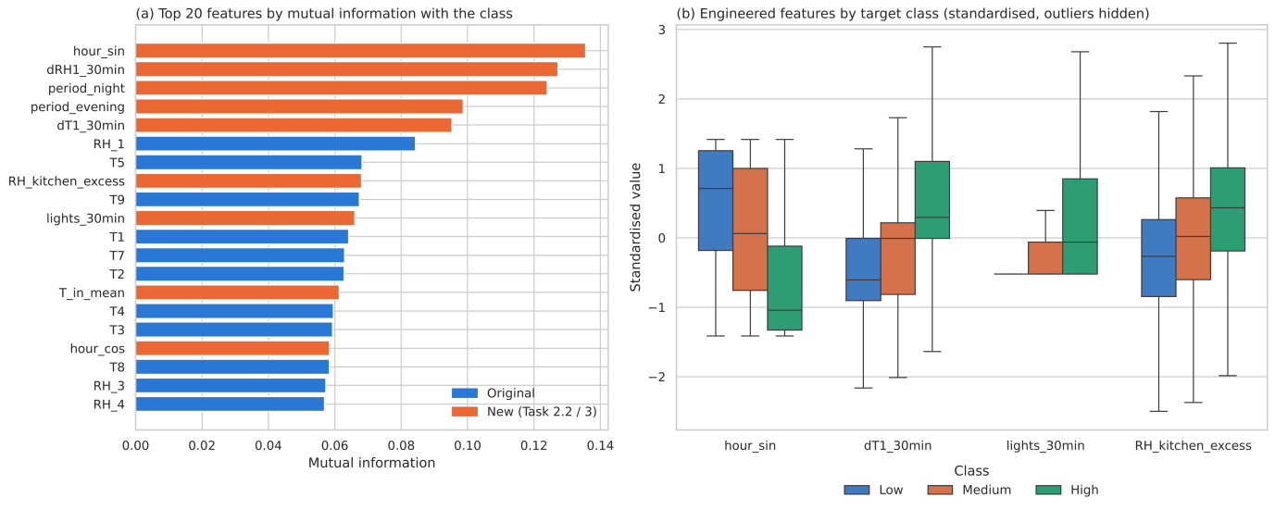
Figure 4: (a) Top 20 features by mutual information (orange = new); (b) engineered features by target class.
- The new features carry more signal than the original sensors. Eight of the ten features most correlated with the target are new: dT1_30min has r = +0.298, compared with +0.197 for lights, the best original feature. On mutual information, hour_sin (0.136), dRH1_30min (0.127), period_night (0.124), period_evening (0.099) and dT1_30min (0.095) all exceed the best original feature (RH_1, 0.084).
- The class medians move in the expected direction: hour_sin falls from 0.50 (Low) to 0.04 (Medium) and −0.74 (High), because High readings occur in the afternoon and evening. RH_kitchen_excess rises from −1.51 to −0.92 and −0.09 (the kitchen becomes humid relative to the house while cooking), lights_30min is 0 for Low and Medium but 10 Wh for High, and the kitchen temperature tends to rise before High readings (dT1_30min median +0.03 °C vs −0.07 °C for Low).
- Non-monotonic signal: dRH1_30min has the second-highest mutual information but almost no rank correlation (ρ = −0.075). Kitchen humidity both rises (steam) and falls (ventilation, door opening) around cooking, so a large change in either direction indicates activity. Linear tests would miss this feature.
- Weak features: is_weekend (MI 0.006) and period_morning (0.003) add little, which confirms the weak weekday effect found in PA1 §5.2.1. They are kept for transparency, and Task 8 lets the data decide.
- Multicollinearity: the aggregates are collinear with their parts by design (T_in_mean vs T9: r = 0.955; RH_in_mean vs RH_4: 0.925), T_in_out_diff mirrors T_out (r = −0.954), and lights_30min follows lights (0.913). This redundancy does not hurt Decision Trees, but it motivates the feature selection and PCA steps for the SVM (Tasks 8–9).
5. Decision Tree Modelling on Five Feature Sets (Task 4)
Following Studio 3 (Activity 1), five Decision Trees (default settings, random_state = 42) were built so that each comparison isolates one preprocessing step (Table 6). Before modelling, the data (all features and the target) was shuffled once and saved to a separate file (data/shuffled_modelling_data.csv.gz), as required by Studio 3 (Activity 3). Every model in Tasks 4–10 uses this file, the same stratified 70/30 split and the same five CV folds.
Table 6: The five Decision Tree models.
Model | Feature set (brief idea) | Normalised | Inputs | Comparison it supports
Model 1 | Original features (Set 1) | No | 24 | baseline
Model 2 | Original features (Set 1) | Yes | 24 | normalisation (1 vs 2)
Model 3 | Original + engineered (Set 3) | Yes | 42 | feature engineering (2 vs 3)
Model 4 | Domain-selected (Set 5 / minimal set) | Yes | 13 | feature selection (3 vs 4)
Model 5 | Domain-selected (Set 5 / minimal set) | No | 13 | normalisation, selected set (4 vs 5)

- Selected features (13): time of day (hour_sin, hour_cos), occupancy (lights_30min), kitchen activity (dT1_30min, dRH1_30min, RH_kitchen_excess), living room T2 (top-3 correlated, PA1 §5.2), laundry room T3, bathroom (RH_5, dRH5_30min), thermal state of the house (T_in_mean) and weather (T_out, RH_out).
- Link to the brief's feature-set ideas: the rubric allows at most five trees, so dimensionality reduction (Set 4) is evaluated with PCA in Task 9 and selection by the strength of the relationship with the target (Set 2) with SelectKBest in Task 8.
- No data leakage: in Studio 2/3 the normalised sets are saved as CSV files. Here the scaling is a step of a scikit-learn pipeline, so each scaler is fitted on the training rows only and refitted in every CV fold.
Table 7: Detailed Decision Tree results (best value in bold).
Model | 70/30 accuracy | 5-fold CV (mean ± std) | Macro-F1 | Train accuracy | Depth | Leaves
Model 1: Original (raw) | 0.6845 | 0.6890 ± 0.0080 | 0.6813 | 1.0000 | 39 | 2,955
Model 2: Original (normalised) | 0.6879 | 0.6883 ± 0.0083 | 0.6843 | 1.0000 | 41 | 2,954
Model 3: Original + engineered (normalised) | 0.6815 | 0.6927 ± 0.0081 | 0.6782 | 1.0000 | 37 | 2,593
Model 4: Selected (normalised) | 0.6656 | 0.6725 ± 0.0048 | 0.6629 | 1.0000 | 36 | 2,962
Model 5: Selected (raw) | 0.6641 | 0.6752 ± 0.0046 | 0.6624 | 1.0000 | 36 | 2,965

One 70/30 split of a single unpruned tree is noisy: Models 1–3 differ by less than the CV standard deviation. The best tree is therefore chosen on the 5-fold CV mean, which averages five test sets: Model 3.
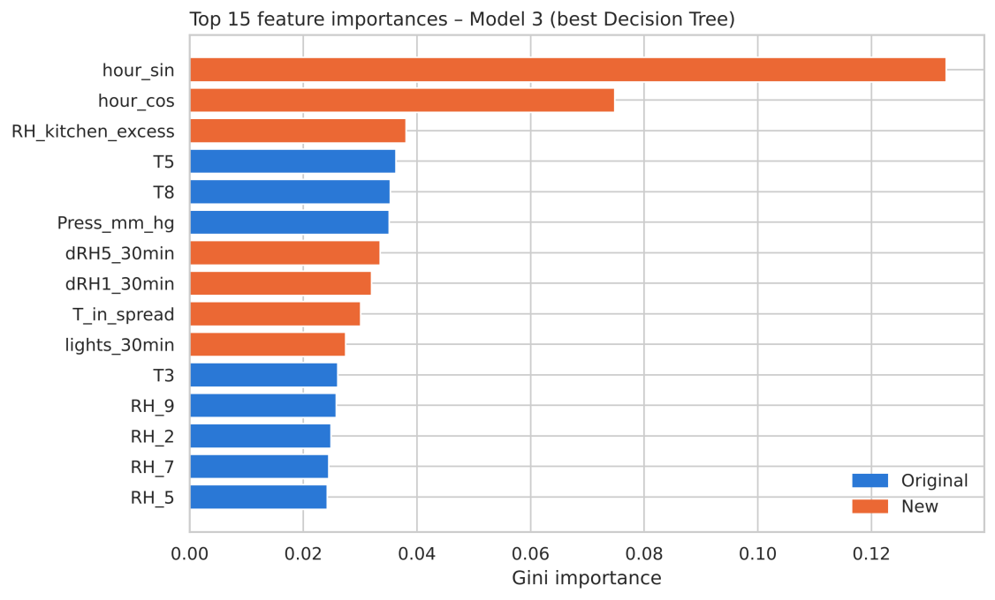
Figure 5: Top 15 feature importances of the best Decision Tree (Model 3; orange = new feature).
Feature importance. hour_sin (0.133) and hour_cos (0.075) are by far the most important features, followed by RH_kitchen_excess (0.038). Seven of the top 10 features are engineered (time of day, kitchen and bathroom changes, temperature spread, recent lights use), and the 18 new features together account for 48.8% of the total importance, so the tree relies mainly on the household routine captured in Task 3.
6. Results Comparison Table (Task 5)
Table 8 is the first summary table in the Studio 3 format. The 5-fold CV row was added because some differences are smaller than the variation between folds.
Table 8: First summary table: Decision Tree accuracy (Studio 3 format).
 | Model 1 | Model 2 | Model 3 | Model 4 | Model 5
Accuracy (%) – 70/30 split | 68.45 | 68.79 | 68.15 | 66.56 | 66.41
Accuracy (%) – 5-fold CV | 68.90 | 68.83 | 69.27 | 67.25 | 67.52

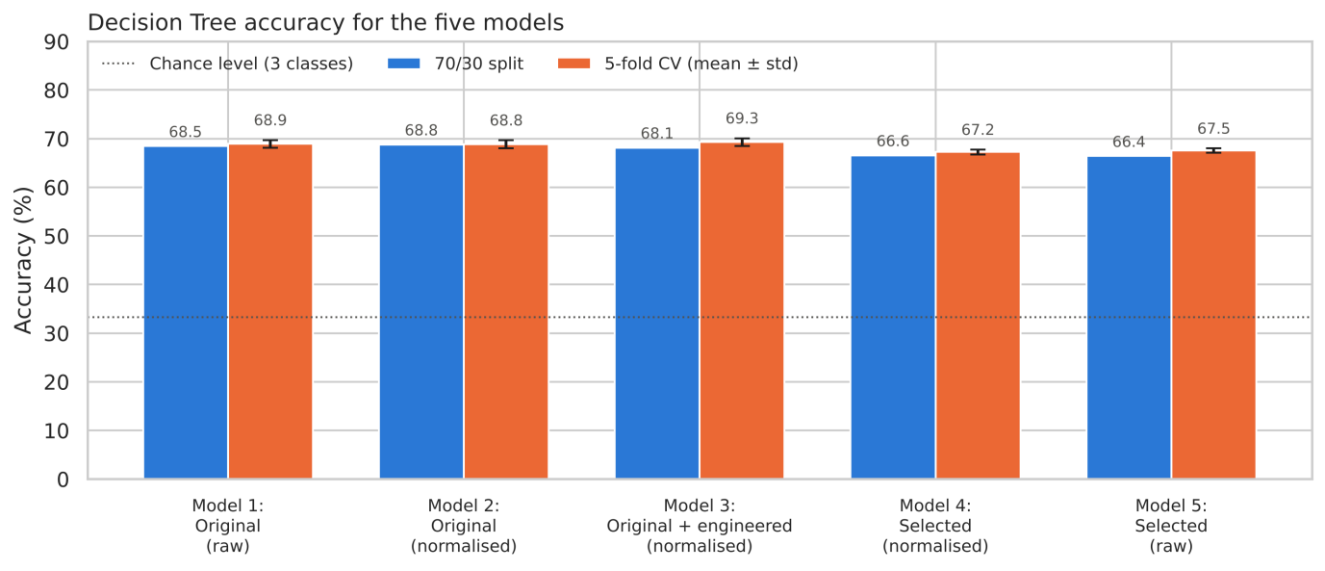
Figure 6: Decision Tree accuracy for the five models (70/30 split and 5-fold CV).
Reflection questions (Studio 3, Activity 2)
1. Which feature set performed best? Why do you think that is? On the 70/30 split, Model 2 (original, normalised) scores highest (68.79%). However, Models 1–3 lie within 0.64 pp of each other (68.15–68.79%), which is less than the variation between CV folds (standard deviation ≈ 0.8 pp). The 5-fold CV averages five different test sets and ranks Model 3 (original + engineered, normalised) first with 69.27% ± 0.81, ahead of Model 1 (68.90%) and Model 2 (68.83%). Model 3 is therefore taken as the best tree. It is the only model with direct information about the household routine: hour_sin and hour_cos are its two most important features (0.133 and 0.075), and the 18 new features account for 48.8% of the total importance. The gain is small because a fully grown tree can partly rebuild the time of day from the original sensors, since outdoor temperature and humidity follow the daily cycle (PA1 §5.2.1).
2. Did normalisation improve performance? (Model 1 vs Model 2) No. Accuracy changes by +0.34 pp on the split (68.45% → 68.79%) and by −0.07 pp in CV (68.90% → 68.83%), so the sign depends on the evaluation and the difference is noise. A Decision Tree splits on one feature at a time. StandardScaler and the Yeo-Johnson transform are monotonic: they keep the order of the values, so the tree can build the same partitions. The tiny differences come from where the threshold lands. The tree places it halfway between two neighbouring training values, and after a non-linear transform "halfway" corresponds to a slightly different raw value, so a few test readings fall on the other side.
3. Did feature engineering help? (Model 2 vs Model 3) Only slightly for the tree: −0.64 pp on the split (68.79% → 68.15%) but +0.44 pp in CV (68.83% → 69.27%). The tree does use the new features heavily (48.8% of the importance) and needs fewer leaves (2,593 vs 2,954), so it finds a simpler description of the data with the same accuracy. The engineered features matter much more for the SVM (+3.4 pp, Task 10.1), and the five features with the highest F-scores are all engineered (Task 8). An unpruned tree also gets more ways to overfit when more features are added.
4. Was feature selection effective? (Model 3 vs Model 4) It was effective as a simplification, not as an improvement. Reducing 42 inputs to the 13 domain-selected features costs 1.59 pp on the split (68.15% → 66.56%) and 2.02 pp in CV (69.27% → 67.25%). The model keeps about 97% of the accuracy with 31% of the inputs. The removed features (for example RH_8, RH_9 and Press_mm_hg, which were among the most important features of Model 2) still carry some information that the tree loses.
5. Is normalisation always necessary? (Model 4 vs Model 5) No, not for trees: 66.56% (normalised) vs 66.41% (raw) on the split, and 67.25% vs 67.52% in CV. The sign flips again, so the difference is noise, which confirms Question 2 on a second feature set. Normalisation is necessary for distance-based or gradient-based models such as SVM, k-NN and neural networks. The same SVM drops from 66.5% to 51.0% without normalisation (Task 10.1). For a tree, scaling can be skipped, which keeps the split thresholds in physical units (°C, %, Wh) and makes the tree easier to read.
6. What pattern do you observe across the five models?
- What the features contain matters more than how they are scaled. The two pairs that differ only in normalisation (1/2 and 4/5) are within 0.35 pp of each other, while the pairs that differ in their features differ by 1.5–2 pp.
- All trees overfit strongly. Each reaches 100% training accuracy with a depth of 36–41 and 2,593–2,965 leaves, so there is a gap of 31–34 pp between training and test accuracy.
- All five models are close (66.4–68.8% on the split). The fully grown single tree is the limiting factor, more than the features. Pruning, ensembles or a smoother model (SVM, Task 6) are needed to go further.
- Medium is the hardest class for the best tree: recall 0.53, compared with 0.71 for Low and 0.80 for High.
7. Model Improvement with SVM (Task 6)
A support vector classifier (RBF kernel, default C = 1 and gamma = 'scale') was trained on all 42 prepared features (original + engineered, final per-feature scaling inside the pipeline), so that Tasks 8 and 9 can select or reduce from the full set. Following Studio 3 (Activity 3), it was evaluated on the 70/30 split and with 5-fold stratified cross-validation (Table 9).
Table 9: SVM baseline compared with the best Decision Tree.
Model (same 42 features) | 70/30 split | 5-fold CV (mean ± std) | Macro-F1 (split)
Best Decision Tree (Model 3) | 68.15% | 69.27% ± 0.81 | 0.6782
SVM baseline (RBF, C = 1, gamma = 'scale') | 69.85% | 70.08% ± 0.38 | 0.6858

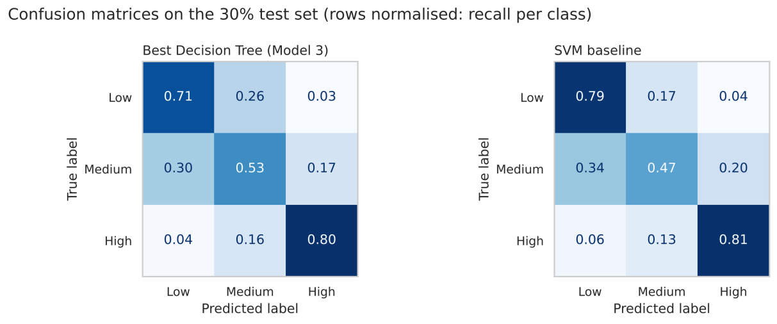
Figure 7: Confusion matrices on the test set, normalised by row (recall per class).
- SVM vs Decision Tree: with the same 42 features, the same split and the same folds, the baseline SVM reaches 69.85% on the 70/30 split (+1.70 pp over Model 3's 68.15%) and 70.08% ± 0.38 in 5-fold CV (+0.81 pp over 69.27% ± 0.81). The smooth RBF decision boundary generalises better than a fully grown tree, which memorises the training data.
- Stability: the split and CV results agree within 0.25 pp, and the CV standard deviation of the SVM is half that of the tree (0.38 vs 0.81 pp), so the SVM is also the more stable model.
- Errors by class: Low (recall 0.79) and High (0.81) are recognised well, but Medium is not (0.47); 34% of the Medium readings are predicted as Low. Compared with the best tree, the SVM is better on Low (0.79 vs 0.71) and High (0.81 vs 0.80) but worse on Medium (0.47 vs 0.53): with default settings, the smooth boundary pushes the narrow middle class towards its neighbours. Confusions between the two extreme classes are rare (4–6%), so the errors respect the ordinal structure of the classes. Medium spans only 60–80 Wh and lies between the other two classes, as expected in Task 1.
- Model choice: the target is categorical, so a support vector classifier (SVC) is used, not SVR.
8. Hyperparameter Tuning (Task 7)
8.1 Kernel selection
Following Studio 3 (Activity 4), four kernels were first compared with default settings on the 70/30 split (Table 10).
Table 10: Kernel comparison (default C and gamma).
Kernel | 70/30 accuracy | Fit time (s)
linear | 62.57% | 15.5
poly (degree 3) | 68.20% | 9.7
rbf (selected) | 69.85% | 11.3
sigmoid | 48.93% | 11.7

8.2 GridSearchCV
For the RBF kernel, GridSearchCV searched C ∈ {1, 10, 100} (penalty for misclassified training points) and gamma ∈ {'scale', 0.01, 0.1, 1} (reach of each training point), with 5-fold stratified CV on the training split only, so the test set stayed unseen until the final evaluation (Figure 8).
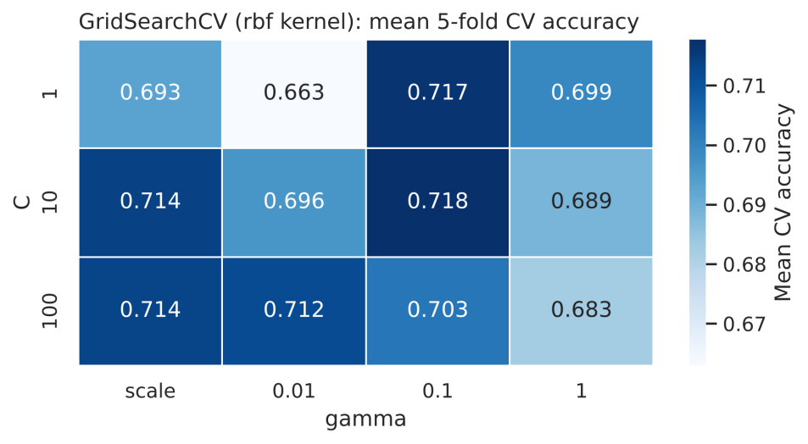
Figure 8: Mean 5-fold CV accuracy for each combination of C and gamma (training split).
Table 11: Effect of hyperparameter tuning.
SVM | 70/30 split | 5-fold CV (mean ± std) | Macro-F1 (split)
Default (C = 1, gamma = 'scale') | 69.85% | 70.08% ± 0.38 | 0.6858
Tuned (C = 10, gamma = 0.1) | 72.56% | 73.43% ± 0.88 | 0.7193
Improvement | +2.70 pp | +3.35 pp | +0.0335

- Kernel selection: with default settings, the RBF kernel performs best (69.85%), ahead of polynomial (68.20%), linear (62.57%) and sigmoid (48.93%). The linear kernel is 7.3 pp worse, so the classes are not linearly separable. For example, High consumption depends on the combination of time of day and activity (lights, kitchen changes), not on any single feature. The sigmoid kernel is far behind: it is not a valid (positive semi-definite) kernel for many settings, and it is only 11 pp above the majority baseline. RBF is selected: it is the most accurate and has only two hyperparameters to tune.
- Grid search: 3 values of C × 4 values of gamma = 12 combinations, each evaluated with 5-fold CV on the training split (60 fits, about 5 minutes). The best combination is C = 10, gamma = 0.1, with a mean CV accuracy of 71.77%. C = 1 with gamma = 0.1 is almost the same (71.67%), so gamma is the parameter that matters.
- Interpretation (bias–variance trade-off): the default gamma = "scale" equals ≈ 0.028 for these features, so the best gamma makes the boundary about 3.5 times more local. A boundary that is too local overfits: gamma = 1 gives 68.26–69.94%, and it gets worse as C grows. A boundary that is too smooth underfits: gamma = 0.01 with C = 1 gives 66.30%. A large C only helps when gamma is small (C = 100, gamma = 0.01: 71.20%) and hurts when gamma is large (C = 100, gamma = 0.1: 70.25%).
- Improvement: the tuned SVM reaches 72.56% on the 70/30 split and 73.43% ± 0.88 in 5-fold CV, which is +2.70 pp (split) and +3.35 pp (CV) over the default SVM. The gain is mainly in the hardest class: Medium recall rises from 0.47 to 0.54, and High from 0.81 to 0.84. The CV accuracy on the full data (73.4%) is higher than the grid-search score (71.8%) because each fold trains on 15,788 rows instead of 11,051.
9. Feature Selection (Task 8)
SelectKBest with the ANOVA F-test (f_classif) was placed inside the pipeline after scaling, so the ranking is learned from the training data only. Following Studio 3 (Activity 5), the SVM uses the tuned hyperparameters from Task 7. K was chosen by scanning K = 5 to 42 on the 70/30 split (Figure 9).
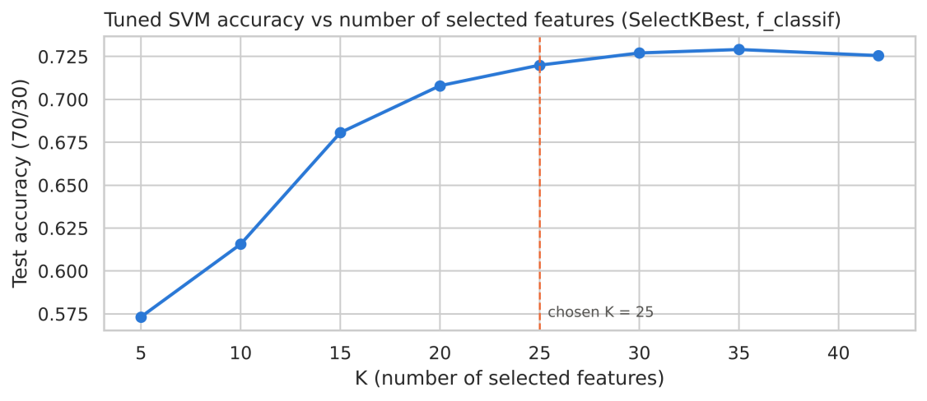
Figure 9: Tuned SVM accuracy as a function of the number of selected features.
Table 12: The 25 features selected by SelectKBest (K = 25), ranked by F-score.
# | Feature | F-score | Type | # | Feature | F-score | Type
1 | hour_sin | 2,008.6 | new | 14 | T6 | 442.8 | original
2 | period_evening | 1,837.2 | new | 15 | T4 | 400.3 | original
3 | period_night | 1,637.0 | new | 16 | T_out | 389.6 | original
4 | dT1_30min | 1,198.1 | new | 17 | T5 | 353.9 | original
5 | lights_30min | 801.0 | new | 18 | T3 | 335.1 | original
6 | lights | 680.9 | original | 19 | RH_8 | 331.8 | original
7 | lights_on | 677.0 | new | 20 | hour_cos | 326.5 | new
8 | RH_kitchen_excess | 645.0 | new | 21 | T7 | 326.2 | original
9 | T2 | 620.8 | original | 22 | T9 | 296.4 | original
10 | RH_out | 550.6 | original | 23 | T_in_out_diff | 248.9 | new
11 | T8 | 517.1 | original | 24 | RH_9 | 213.2 | original
12 | T_in_mean | 456.2 | new | 25 | period_late_evening | 175.7 | new
13 | T1 | 445.4 | original

Table 13: SVM with feature selection and tuning.
SVM | Inputs | 70/30 split | 5-fold CV (mean ± std)
Tuned, all features | 42 | 72.56% | 73.43% ± 0.88
Tuned + SelectKBest (K = 25) | 25 | 72.00% | 72.67% ± 0.35

- Choice of K: accuracy rises steeply up to K = 20 (K = 5: 57.32%, K = 10: 61.56%, K = 15: 68.06%, K = 20: 70.80%) and then levels off (K = 25: 72.00%, K = 30: 72.71%, K = 35: 72.91%, all 42: 72.56%). The best value, K = 35, is only 0.35 pp above using all features. K = 25 is the smallest K within 1 pp of the best and is used. It gives 72.00% on the split and 72.67% ± 0.35 in CV: −0.56 pp and −0.76 pp compared with the tuned SVM on all features, with 40% fewer inputs (25 of 42) and the lowest CV standard deviation of all the SVM models.
- Selected features: the five highest F-scores belong to engineered features: hour_sin (2,009), period_evening (1,837), period_night (1,637), dT1_30min (1,198) and lights_30min (801). In total, 11 of the 25 selected features are new. This confirms the value of the feature engineering in Task 3.
- Removed features (17): mostly humidities (RH_1–RH_5, RH_7, RH_in_mean) and weather variables (Windspeed, Visibility, Press_mm_hg, Tdewpoint), plus is_weekend, period_morning and period_afternoon. This matches the weak correlations of these features in PA1 §5.2.
- Limitation of the ANOVA F-test: the F-test only compares the class means. It therefore removes dRH1_30min, which has the second-highest mutual information in Task 3 and is among the ten most important features of the best tree. Its effect is non-monotonic: kitchen humidity both rises and falls around cooking. A mutual-information score (mutual_info_classif) would be a better criterion for this non-linear problem.
10. Dimensionality Reduction with PCA (Task 9)
PCA was fitted on the scaled training features inside the pipeline. Studio 3 suggests the first 10 components "or choose based on the dataset"; here the number was chosen from the cumulative explained variance (Figure 10) and checked against accuracy with the tuned SVM (Table 14).
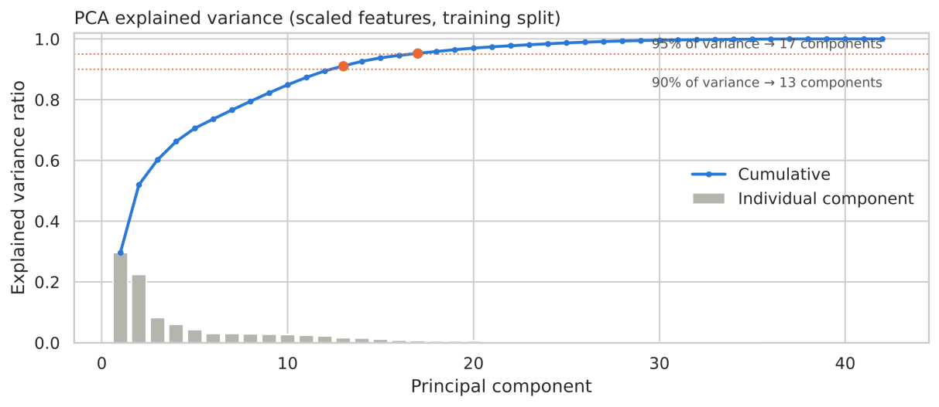
Figure 10: Explained variance of the principal components (training split).
Table 14: Accuracy for different numbers of principal components.
Components | Variance explained | 70/30 accuracy (tuned SVM)
5 | 70.6% | 65.12%
10 (Studio default) | 84.9% | 70.43%
13 (90% of variance) | 91.1% | 71.66%
17 (95% of variance, chosen) | 95.2% | 72.64%
25 | 98.7% | 72.45%

With 17 components, the tuned SVM reaches 72.64% on the 70/30 split and 73.23% ± 0.97 in 5-fold CV.
- Explained variance: the first 5 components explain 70.6% of the variance and the first 10 (the Studio 3 default) explain 84.9%. 13 components reach 90% and 17 components reach 95% of the variance of the 42 scaled features. The data can be compressed this much because the indoor sensors are strongly collinear (PA1 §5.3).
- Choice of the number of components: accuracy rises with the number of components up to 17 and then stops (5: 65.12%, 10: 70.43%, 13: 71.66%, 17: 72.64%, 25: 72.45%). The Studio default of 10 components would lose 2.2 pp, so the number is chosen from the dataset: 17 components (95% of the variance).
- Result: 72.64% on the split and 73.23% ± 0.97 in CV, i.e. +0.08 pp and −0.20 pp compared with the tuned SVM on all 42 features. This is practically the same accuracy with 60% fewer inputs to the SVM.
- Limitations: PCA is unsupervised. It keeps directions of high variance, which do not have to be the most predictive ones, as the poor result with 5 components shows. Each component mixes all the sensors, so the model loses interpretability. Unlike feature selection, PCA does not reduce the number of sensors, because all 42 features are still needed to compute the components.
11. Final Results Table (Task 10)
Table 15 is the final summary in the Studio 3 format. "Original features" is the SVM with its default hyperparameters on all 42 prepared features.
Table 15: Final summary table of the four SVM models (Studio 3 format).
SVM model | Train-test split | Cross-validation | CV std | Inputs | Macro-F1 (split)
Original features (C = 1, gamma = 'scale') | 69.85% | 70.08% | 0.38 pp | 42 | 0.6858
With hyperparameter tuning (C = 10, gamma = 0.1) | 72.56% | 73.43% | 0.88 pp | 42 | 0.7193
With feature selection (K = 25) and hyperparameter tuning | 72.00% | 72.67% | 0.35 pp | 25 | 0.7111
With PCA (17 components) and hyperparameter tuning | 72.64% | 73.23% | 0.97 pp | 17 | 0.7203

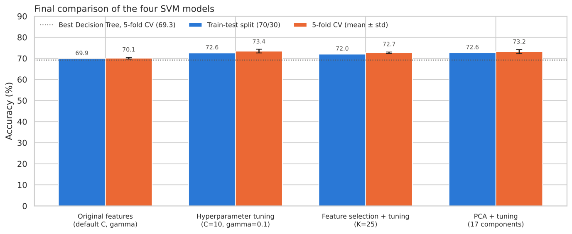
Figure 11: Final comparison of the four SVM models (70/30 split and 5-fold CV).
11.1 Impact of each preprocessing step (Task 10.1)
To compare the techniques on one scale, the SVM was retrained on the same 70/30 split, adding one step at a time (Figure 12).
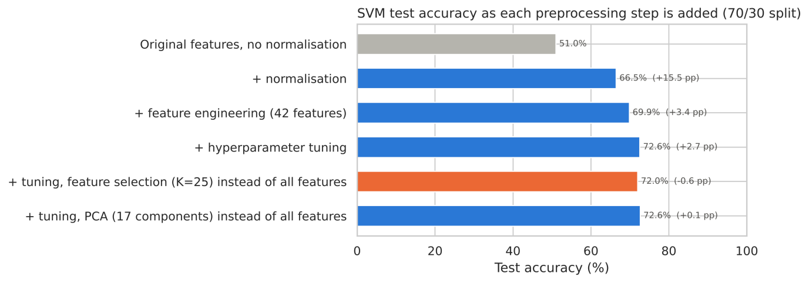
Figure 12: SVM test accuracy as each preprocessing step is added (70/30 split).
11.2 Robustness check: chronological split (Task 10.2)
Table 16: Shuffled vs chronological split (train 11 Jan – 16 Apr, test 16 Apr – 27 May).
Model | Shuffled 70/30 | Chronological 70/30 | Difference
Decision Tree (Model 3) | 68.15% | 43.03% | −25.11 pp
Tuned SVM (C = 10, gamma = 0.1) | 72.56% | 45.60% | −26.95 pp

11.3 Reflection questions (Studio 3, Activity 7) and recommendations
Summary. All three improved SVMs reach 72.0–73.4%. The tuned SVM on all 42 features (C = 10, gamma = 0.1) has the highest CV accuracy (73.43% ± 0.88; 72.56% on the split). The PCA version is equivalent (72.64% split, 73.23% CV): the differences between these two are far below the CV standard deviation. Both are about 4 pp above the best Decision Tree and almost double the majority-class baseline (37.8%).
1. Which preprocessing technique had the biggest impact on model performance? Normalisation, by far, for the SVM. The step-by-step comparison in Task 10.1 shows the SVM on the 24 original features rising from 51.02% without normalisation to 66.48% with it (+15.45 pp). Without scaling, large-valued features such as pressure (≈755 mm Hg) dominate every distance. Feature engineering adds +3.38 pp (69.85%) and tuning +2.70 pp (72.56%). Feature selection (−0.56 pp) and PCA (+0.08 pp) do not improve accuracy; their value is a smaller model (40% and 60% fewer inputs). The answer depends on the model: for the Decision Trees, normalisation made no difference (Task 5, Q2 and Q5) and the choice of features mattered most.
2. Did hyperparameter tuning significantly improve your SVM model? By how much? Yes: +2.70 pp on the split (69.85% → 72.56%) and +3.35 pp in CV (70.08% → 73.43%), which removes about 11% of the CV errors (error rate 29.9% → 26.6%). The gain appears in both evaluation methods and is several times larger than the fold-to-fold standard deviation (0.4–0.9 pp), so it is a real improvement. It comes mainly from gamma (0.1 instead of the default ≈ 0.028).
3. Decision Tree (Activity 1) vs SVM (Activity 7): which performed better for this dataset? The SVM, in every comparison. The best tree (Model 3) reaches 68.15% on the split and 69.27% in CV; the tuned SVM reaches 72.56% and 73.43%, i.e. +4.41 pp and +4.16 pp. Even the default SVM beats the best tree. The tree memorises the training data (100% training accuracy, about 2,600 leaves), while the RBF-SVM fits a smooth boundary, controlled by C and gamma, that generalises better.
4. Was there a trade-off between model performance and interpretability? Yes.
- The Decision Tree is interpretable in principle. Every prediction is a chain of thresholds in physical units, and the feature importances show which inputs drive it (hour_sin, hour_cos, RH_kitchen_excess). In practice, a tree with about 2,600 leaves is too large to read, and it is the least accurate model.
- The tuned SVM is about 4 pp more accurate but is a black box. Its decision is a weighted sum of RBF similarities to 8,750 support vectors (63% of the training rows) in a 42-dimensional scaled space, and it gives no feature importances (permutation importance would be needed).
- Within the SVMs, SelectKBest keeps 25 named features and needs fewer sensors, for −0.6 to −0.8 pp. PCA keeps the accuracy but replaces the features with abstract components, and it still needs all the sensors.
- Choice: the tuned SVM if accuracy is the priority; the SelectKBest SVM, or a pruned tree, if the model has to be explained to a building manager.
Robustness to time (important limitation). With a chronological split (train 11 Jan – 16 Apr, test 16 Apr – 27 May), accuracy falls to 43.03% for the Decision Tree and 45.60% for the tuned SVM (−25.11 pp and −26.95 pp). The shuffled split of Studio 3 is optimistic for two reasons:
- Neighbouring 10-minute readings are almost identical (autocorrelation 0.75), so the test set contains near-copies of training points.
- The house changes from winter to spring (non-stationarity, PA1 §4.4). The class mix also shifts: Medium makes up 39.4% of the test period compared with 30.6% overall.
The SVM keeps the advantage over the tree, but the chronological result is the more realistic estimate for predicting future consumption.
Recommendations.
- Use the tuned SVM with the engineered time and activity features as the current best model, but report its performance with time-based validation (for example, TimeSeriesSplit).
- Add lagged consumption and more months of data (including summer), so that the model sees every season, and retrain it regularly to handle drift.
- Select features with mutual information rather than the F-test, to keep non-linear features such as dRH1_30min.
- Try tree ensembles (Random Forest, gradient boosting). They reduce the overfitting of single trees and still give feature importances.
References
Candanedo, L. (2017). Appliances Energy Prediction [Dataset]. UCI Machine Learning Repository. https://doi.org/10.24432/C5VC8G
Candanedo, L. M., Feldheim, V., & Deramaix, D. (2017). Data driven prediction models of energy use of appliances in a low-energy house. Energy and Buildings, 140, 81–97. https://doi.org/10.1016/j.enbuild.2017.01.083
Pedregosa, F., et al. (2011). Scikit-learn: Machine learning in Python. Journal of Machine Learning Research, 12, 2825–2830.
Swinburne University of Technology. (n.d.). Acknowledgement of Country. https://www.swinburne.edu.au/about/our-university/indigenous-matters/acknowledgement/

Appendix A – Evidence of Generative AI use:
Rubric analyzing:
